Pima-Maricopa Irrigation Project Education Initiative
2005-2006

Restoring water to ensure the
continuity of the Akimel O’otham
and Pee Posh tradition of agriculture

Surveying the Pima Reservation: 1859

Sylvester Mowry did more than distribute the gifts Congress made available to the Pima and Maricopa under the 1859 act. He also supervised the survey of the Pima Reservation. While expecting to survey a 240,000 acre reservation, the agent was ordered to limit the reservation to an area “not to exceed the limit specified by Congress,” or 64,000 acres. He had $1,000 at his disposal to conduct “a cheap kind of survey.”
Part 70

When Mowry traveled to the villages to distribute the gifts, engineer Andrew B. Gray accompanied him. Charged with the actual survey of the reservation, Gray was already familiar with the Pima villages from his days as a surveyor with the Mexican Boundary Survey and the Pacific Railroad survey of 1855. How Gray surveyed the reservation reveals much about the perceived threat to the Pima and Maricopa villages in 1859.
Gray and Mowry met with Antonio Azul and the village leaders to discuss the survey. As Mowry made clear in his report, the Americans were not particularly concerned with Pima and Maricopa desires. Writing to Greenwood, Mowry noted the difficulty he had explaining to Azul and the headmen the nature and purpose of the survey as the Americans saw it. Azul repeatedly argued the Pima and Maricopa “claimed as their own property the entire Gila valley on both sides,” from the Pinal Mountains east of Florence to the Little Desert near Gila Bend. To mitigate Pima concerns over the limits of the reservation, Mowry told Azul the survey was to protect and enclose their “present villages and planting grounds” and clearly mark them to prevent encroachments by settlers. If the Pima and Maricopa “held a valid title to any lands beyond the present survey,” the United States Government would consider it at a future date.
Reportedly pleased with these assurances, Azul and the other headmen consented to survey parties beginning work. Mowry remained in the field with Gray only long enough to establish the initial points of the reservation and the general lines that would run on both sides of the Gila River to encompass both the Pima villages and their cultivated fields. As we shall see, this was critical to determining where and for what purpose the boundary line was drawn. Mowry—having already solicited Pima and Maricopa desires for the gifts distributed that fall, then departed for San Francisco to make the necessary purchases. Gray returned to Tubac, where he waited for the “excessive [summer] heat” to pass before beginning the survey. Returning the Pima villages on September 5, 1859, Gray spent the next forty-three days working to complete the survey, chaining nearly seventy miles of land in order to fix the limits of the reservation and include all the Pima “gardens or planting grounds” along the middle Gila. As importantly, Gray informed Mowry that the reservation protected “a great extent of water for their acequias” and the mesquite forest that the surveyor referred to as “abundantly wooded.” The thick mesquite, arrow-weed and desert underbrush was a constant battle for Gray and on some days the men proceeded no more than a mile. Gray and his work parties worked from sunup to sundown for all but four of the 43 days—with these four days spent taking astronomical observations at night and completing field notes. Gray informed Mowry of the completed survey on October 17.
The reservation was in essence two trapezoids each twelve and a half miles in length and connected at their ends. Each was four miles in width and, combined, the reservation encased nearly 26 miles of the Gila River and its flood plains and lower terraces that included the “Indian gardens,” “cultivated grounds,” and “Pimo Villages.” None of the villages is named and glaringly absent from the 1859 reservation were the Maricopa villages and fields located downstream of Pima Butte, and a number of upstream Pima fields that had previously been cultivated near the Blackwater spring. In his final report to Greenwood, Mowry indirectly noted these lands, stating, “The attention of the department is respectfully called to the necessity of an early settlement of the titles of the Pimo and Maricopa Indians to the lands above and below their present reservation on the Gila.” With the United States Army contemplating the establishment of a military post near the villages, Mowry recognized such an action would “at once induce settlement by Americans and Mexicans.”
The 1859 act specified land be set apart “for the confederated bands of Pimas and Maricopas.” The actions of the Butterfield Overland Mail Company can explain the exclusion of the Maricopa villages and fields. In June of 1859, Greenwood instructed Mowry to survey the reservation, reminding the agent of what he already knew: The Butterfield Overland Company had established a station in Casa Blanca. “As your survey may embrace it, you can say to the Indians, if they consent to its occupancy, that such will confer no title upon the contractors but it will revert to them immediately upon the discontinuing the use of it for the purpose now occupied, but, of course, if they do not give their consent the contractors will have no right to its use, but must abandon it.”
Greenwood was concerned that the Butterfield Company would seek to claim 320 acres of land in the midst of the villages. “You should apprize the contractors that their occupancy of the land at that point can confer no title upon them to the same, either at present or prospectively,” a directive with which Mowry immediately complied. In October, Silas St. John informed Mowry that Gray had heard from the Butterfield Overland Company and that it was claiming 320 acres “at this place,” a reference to Casa Blanca. Buckley further informed Gray that the newly established Indian Agency was on the ground claimed by the mail company. “To my knowledge,” St. John elaborated, “the company neither owned nor claimed any land or property here prior to July 3, 1859.” This date was important, as the Pima had agreed to set aside the same ground for agency purposes on May 30, with construction of the buildings commencing in June.
When Gray surveyed the reservation, he told Mowry he had included all the water of the Pima and Maricopa canals when, in fact, he hadn’t. The survey was not as “advantageous” as Gray explained it to be, since he omitted protecting the head and upper portions of the Little Gila River and all the Blackwater spring and slough. Also omitted were the irrigated island lands between the Gila and Little Gila. These lands were east and north of the main overland road winding its way from Tucson and had been previously cultivated even though they were not then under cultivation.
What Gray and Mowry appear to have done was lay out a reservation that protected the wagon roads and stage stations. This might explain why Azul and the chiefs had difficulty in understanding the motives of the survey, as Mowry reported to Greenwood. Azul claimed for the Pima all the land on both sides of the river from the Pinal Mountains to Gila Bend. Gray—with the tacit approval of Mowry—sought to define the boundaries of the reservation in such a way as to strategically protect what the Indian Department perceived as an imminent threat from the Butterfield Overland Company to patent prime land within the reservation—and perhaps position themselves to control the Pima wheat market.
Gray surveyed the reservation for two miles on either side of the Gila River. This, too, was prudent, as it encompassed Casa Blanca and the Indian agency as well as—and more importantly—the lands surrounding the Butterfield station in Casa Blanca. Clearly, Mowry and Gray recognized the threat the Butterfield Overland Company posed to the Pima and Maricopa. Nonetheless, by protecting the roads and eastern stage stops, Gray was unable to envelop Maricopa Wells within the reservation. Consequently, this station continued to grow and served as the transportation hub of southern-central Arizona until the late 1870s. The failure to include the Maricopa villages and fields downstream was defensible, Gray likely concluded, because stage traffic turned southwest over the forty mile desert from Maricopa Wells rather than continuing northwest along the Gila through the Maricopa villages, posing little or no immediate threat to the Maricopa. As Mowry had made clear to Antonio Azul and the other headmen, the reservation was not intended to limit the Pima and Maricopa to 64,000 acres but was, indirectly, designed to protect their cultivated fields and village sites as well as the main transportation routes from encroachment—from the Butterfield Overland Mail Company in particular.
The surveyed reservation points to another important point. When Mowry met with the chiefs and headmen, he assured them the protection of their rights to additional land and that “full justice would be done them by the United States government in this and every other respect.” Clearly, Azul and the headmen understood that their lands would be protected and—with the distribution of agricultural implements and tools—they could expect to subjugate additional land, which implied the diversion of additional quantities of water. Accomplishing this could occur only by expanding the original reservation. Mowry implied as much in his statement to Greenwood that “any extensive cultivation above the Indian fields will cause trouble about water for irrigation, and inevitably bring about a collision between settlers and the Indians.”
Consequently, the 1859 survey spoke volumes to the importance of Pima and Maricopa agriculture to the future development of Arizona. Not only did the survey protect the immediate villages and fields, but it was also interpreted by the Pima and Maricopa as the first step in providing them with additional technology and the support necessary to expand their agricultural endeavors. The Pima and Maricopa had every reason to believe this course of events would indeed transpire in the coming years.

Original Survey of the 1859 Pima Reservation Protecting Existing Agricultural Fields.
(Source: National Archives, Washington DC)

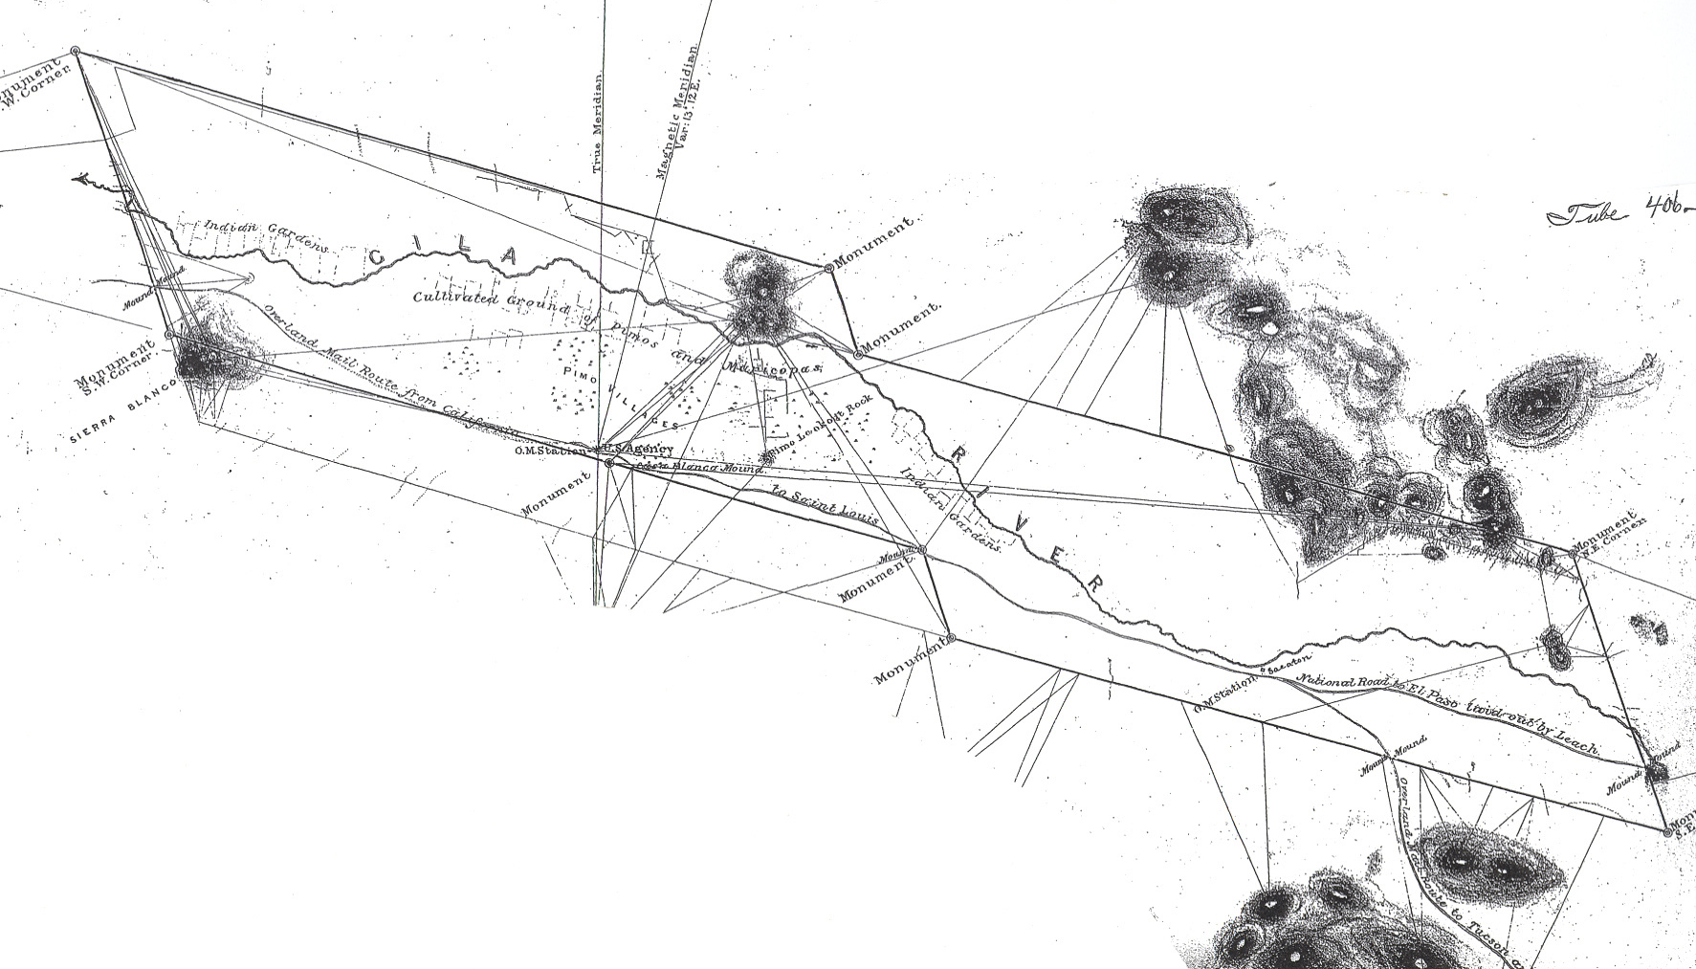
Sacaton Station
Indian Agency
(Casa Blanca)
Indian Agency
(Casa Blanca)
Teacher Plan for “Surveying the Pima Reservation: 1859”

Objectives

Students will be able to:

- Use a map of the modern reservation and determine which villages were protected and those unprotected by the 1859 survey.

- Synthesize information and make a judgment on the relative protective nature of the 1859 reservation.
Terms to know and understand
- Mitigate
- Encroachment
- Astronomical
- Trapezoid
- Prospective
- Slough

Critical Thinking:

- Assuming you were alive in 1859, would it be more important to you to have the Maricopa villages and fields and/or upstream Pima fields included within the reservation or to protect Casa Blanca from the Butterfield Overland Mail Company securing land rights—and potentially an advantage in wheat acquisition? Explain your reasoning.

Activities:

- Using the P-MIP map of the reservation (copies are available from P-MIP by calling (520) 562-6742), list those villages protected and unprotected by the 1859 reservation. Which villages were in the center of the reservation as it existed in 1859?

About P-MIP

The Pima-Maricopa Irrigation Project is authorized by the Gila River Indian Community to construct all irrigation systems for the Community. When fully completed, P-MIP will provide irrigation for up to 146,330 acres of farmland. P-MIP is dedicated to three long-range goals:
- Restoring water to the Akimel O’otham and Pee Posh.
- Putting Akimel O’otham and Pee Posh rights to the use of water to beneficial use.
- Demonstrating and exercising sound management to ensure continuity of the Community’s traditional economy of agriculture.

